**ADT Lab 11 (10pts)**

**Neo4j Sandbox**

In this lab, we will be exploring the graph data science library using the Neo4j sandbox cluster.

To access the Neo4j sandbox cluster, follow this link:

[Neo4j Sandbox](https://sandbox.neo4j.com/)

(If you are facing issues in Sandbox you can work in Neo4j Desktop as well. However, we strongly recommend using Neo4j Sandbox for this lab to familiarise with different tools)

Login to the sandbox:

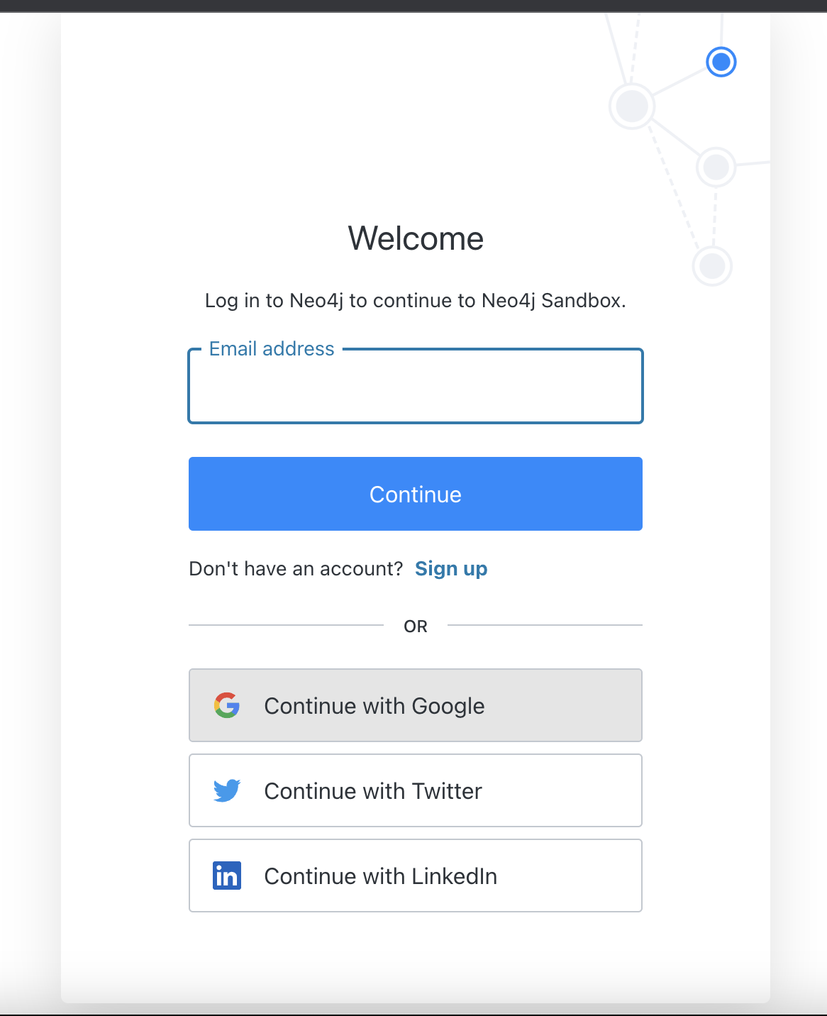

Once logged in, click on the **New Project** button.

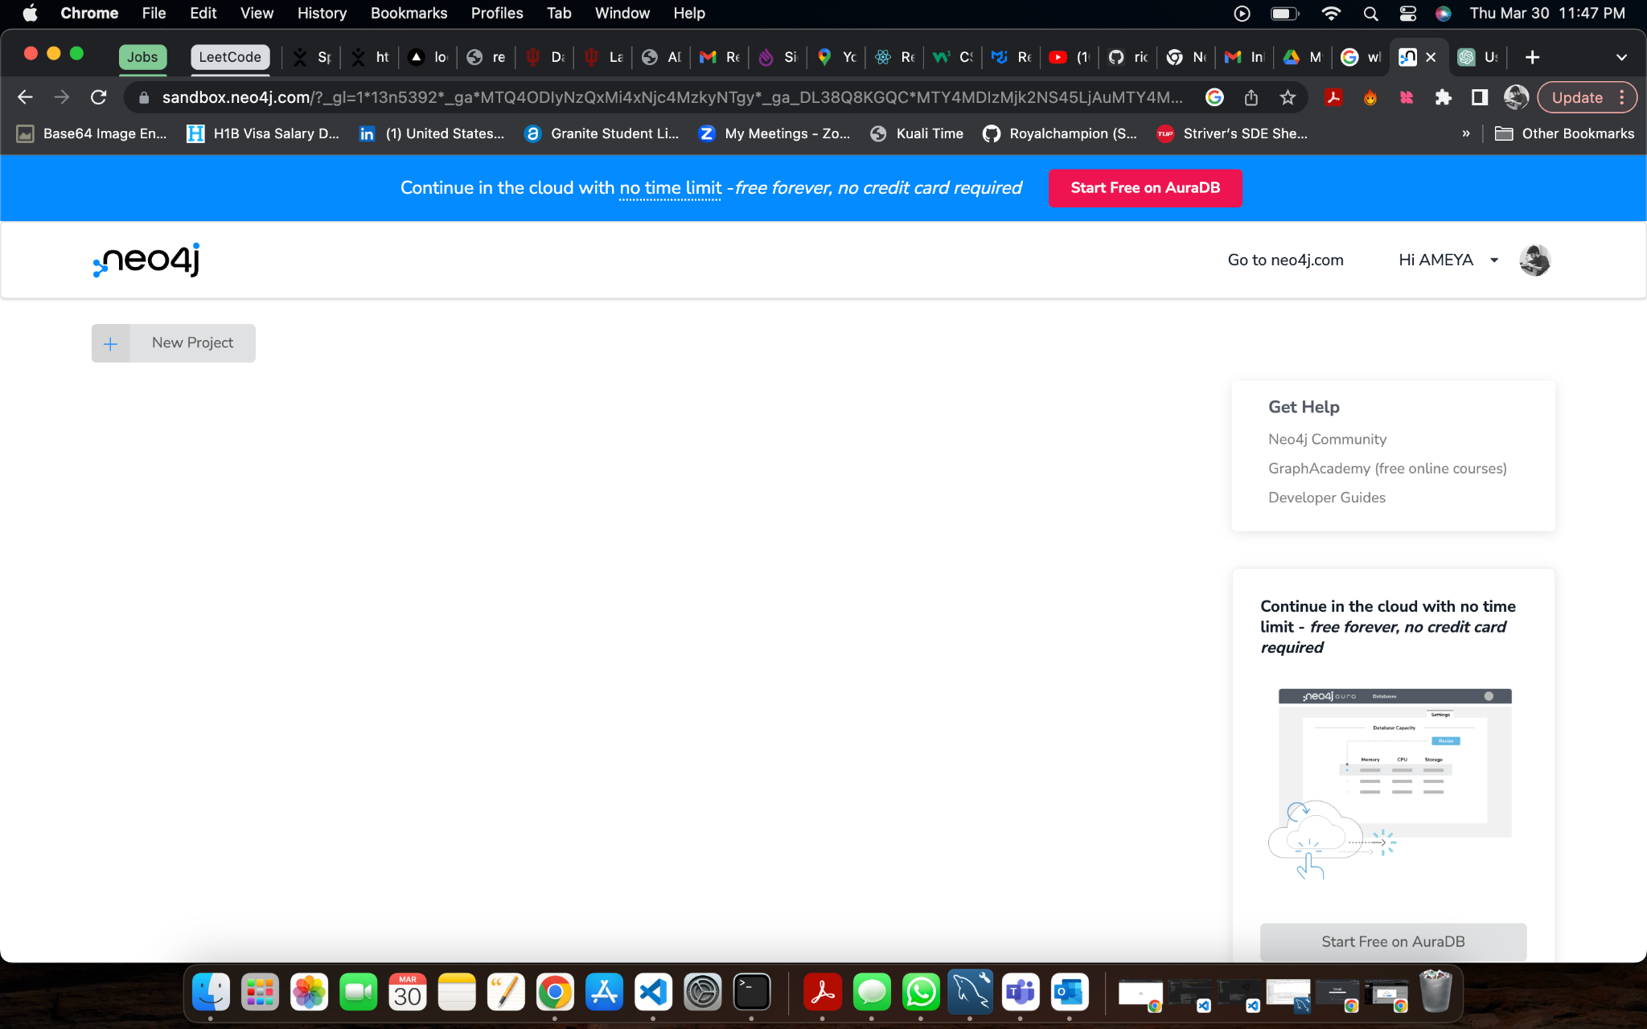

We will be using the **Graph Data Science** featured dataset provided by Neo4j.

The airport database is a sample graph database provided by Neo4j that contains information about airports, airlines, and flights. It is designed to showcase the capabilities of Neo4j as a graph database and to provide a starting point for building more complex graph-based applications.

The airport database consists of nodes representing airports, airlines, and countries, and relationships between these nodes represent flights and routes. The data is based on the OpenFlights data set, which contains information about airports, airlines, and routes from around the world.

To access the airport database in Neo4j Sandbox, you can create a new sandbox and select the "Airports" option from the list of available templates. Once your sandbox is created, you can access the Neo4j Browser and explore the airport database using Cypher queries.

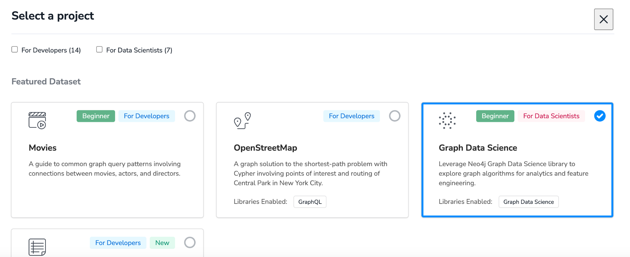

You will this screen. In the database section, type “Lab 11” and use the Sandbox Login button to start the connection.

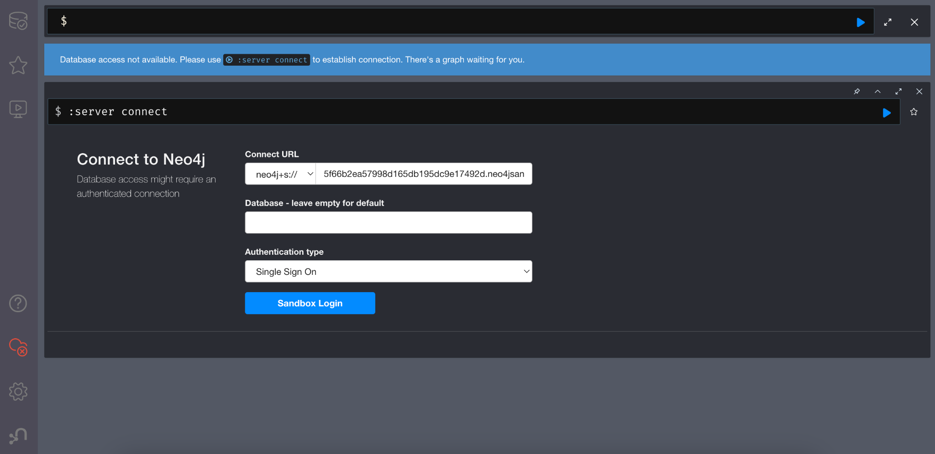

You can also access this dataset using Neo4j Desktop.

1. Create a new Project and Database.
2. Run command :play sandbox/airport-routes/index.html
3. Follow the steps and execute queries to load data.

To understand better how the Graph Data Science library is used you can watch this video: <https://www.youtube.com/watch?v=DMfolcSkhRs>

Since you are already aware about performing EDA in Neo4j you can skip to 40:00 in the video to start with GDS library explanation.

After connecting, you should be able to see this screen:-

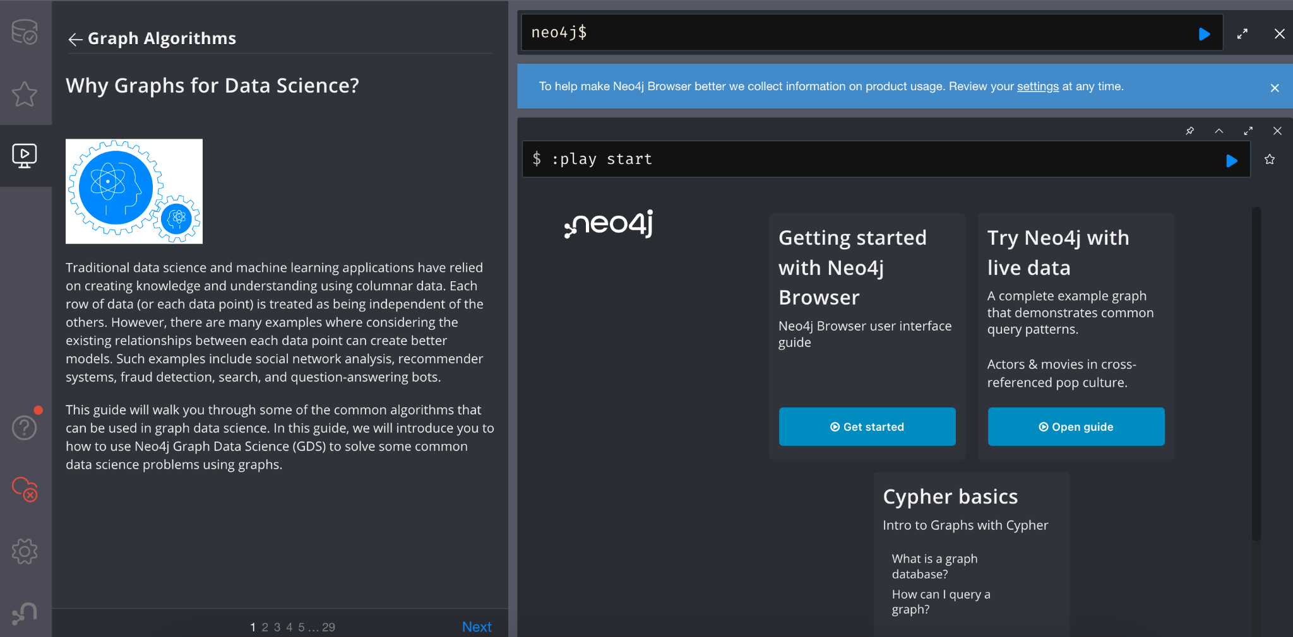

Follow the informative tutorial. The tutorial gives you a very brief idea into how to use Graph Data Science library in Neo4j.

Once done, you should also be able to click on any queries to execute them.

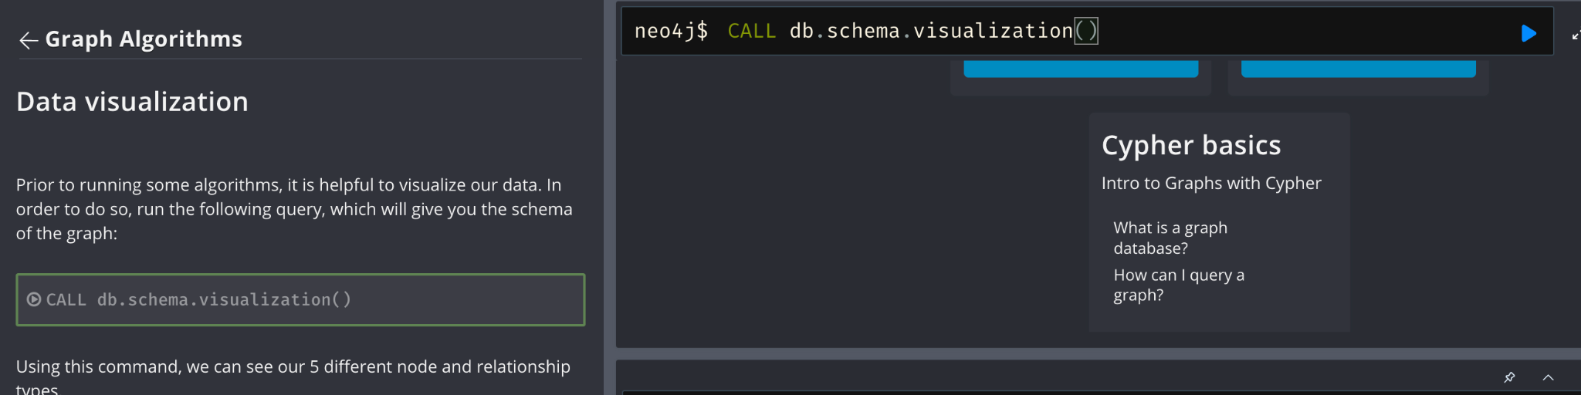

Go through all 29 slides. Once done, post the output following algorithms:

1. **PageRank Algorithm**

Your query output screenshot here:

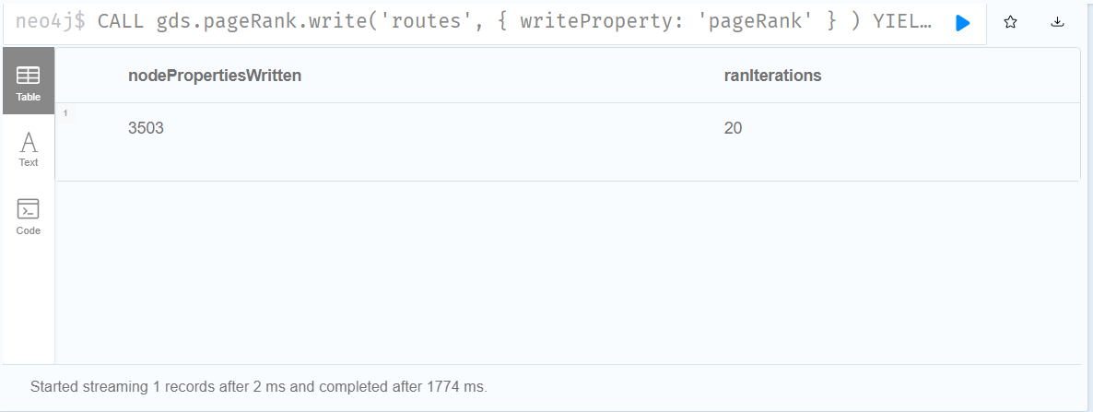

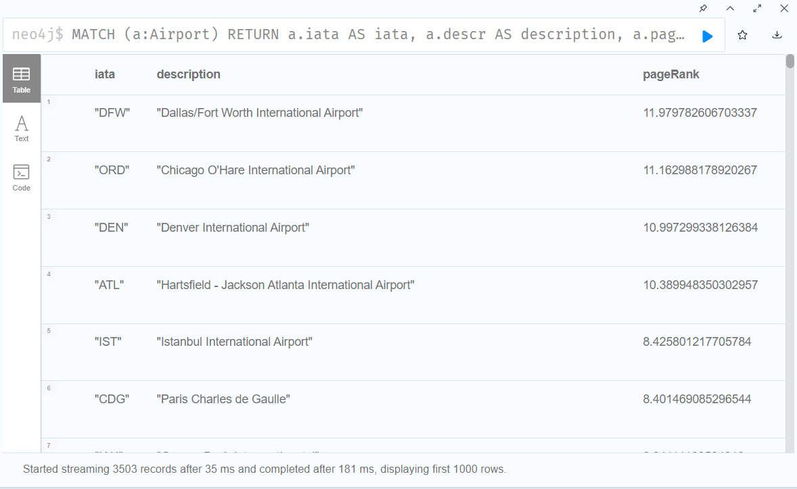

1. **Louvain Modularity**

Your query output screenshot here

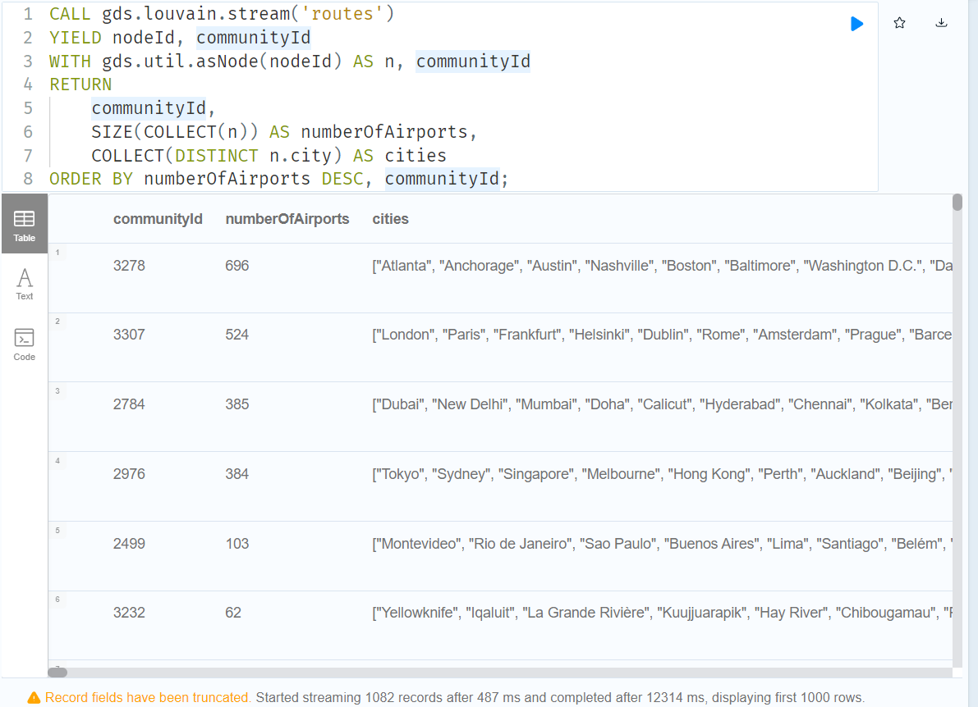

1. **Node Similarity**

Your query output screenshot here:

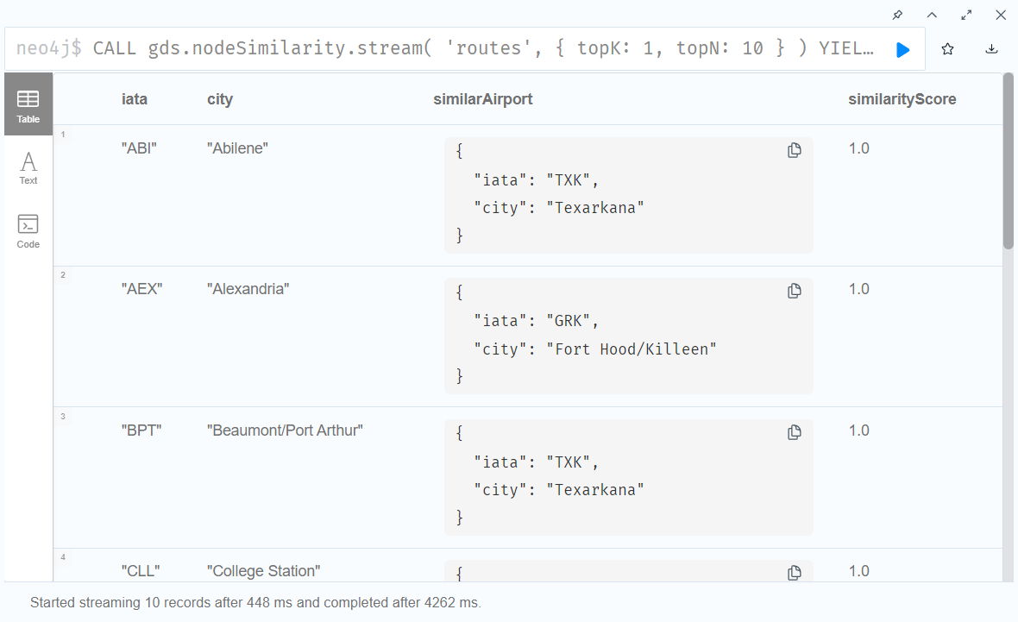

1. **Path Finding (Dijkstra’s Algorithm)**

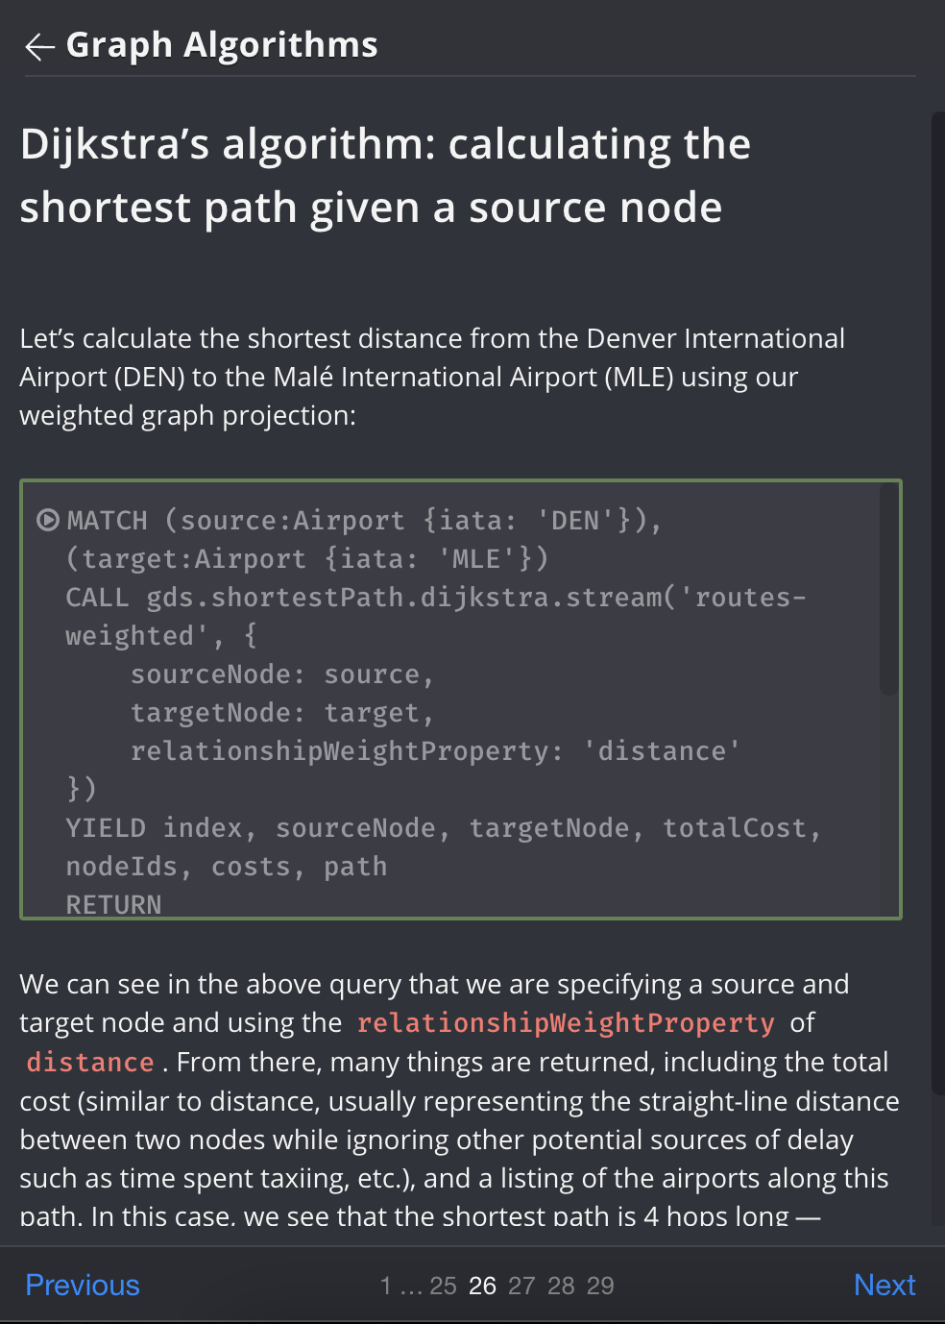

Your query output screenshot here:

